Betfair
All Races:
https://www.betfair.com.au/exchange/plus/en/horse-racing-betting-7
Tips example:
https://www.betfair.com.au/exchange/plus/horse-racing/market/1.186712793
scroll to bottom
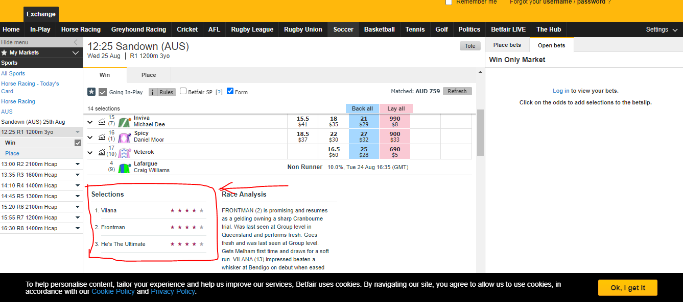

Ladbrokes
All Races:
https://www.ladbrokes.com.au/racing
Tips example:
https://www.ladbrokes.com.au/racing/belmont/479e59d8-e45e-49a5-b9f5-9362cf47f393
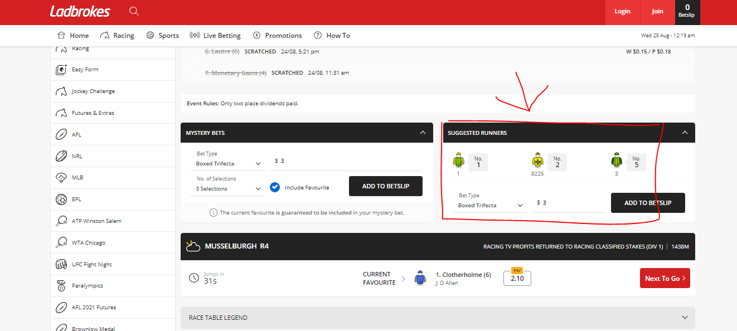

Pointsbet
All Races:
https://pointsbet.com.au/racing
Tips example:
https://pointsbet.com.au/racing/Thoroughbred/AUS/Belmont/race/16442758
Click the preview and tips button
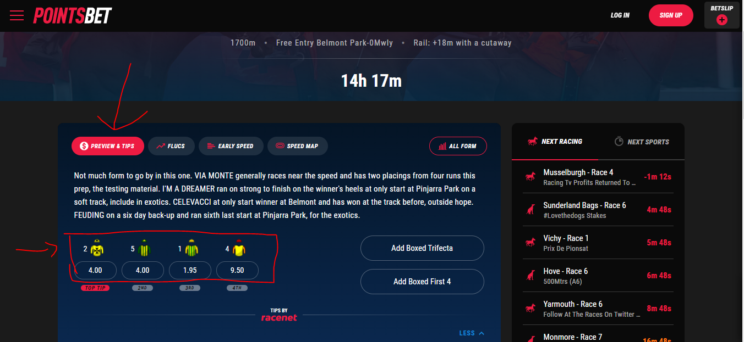

Racenet
All Races:
https://www.racenet.com.au/horse-racing-tips
Tips example:
Click race to open tips
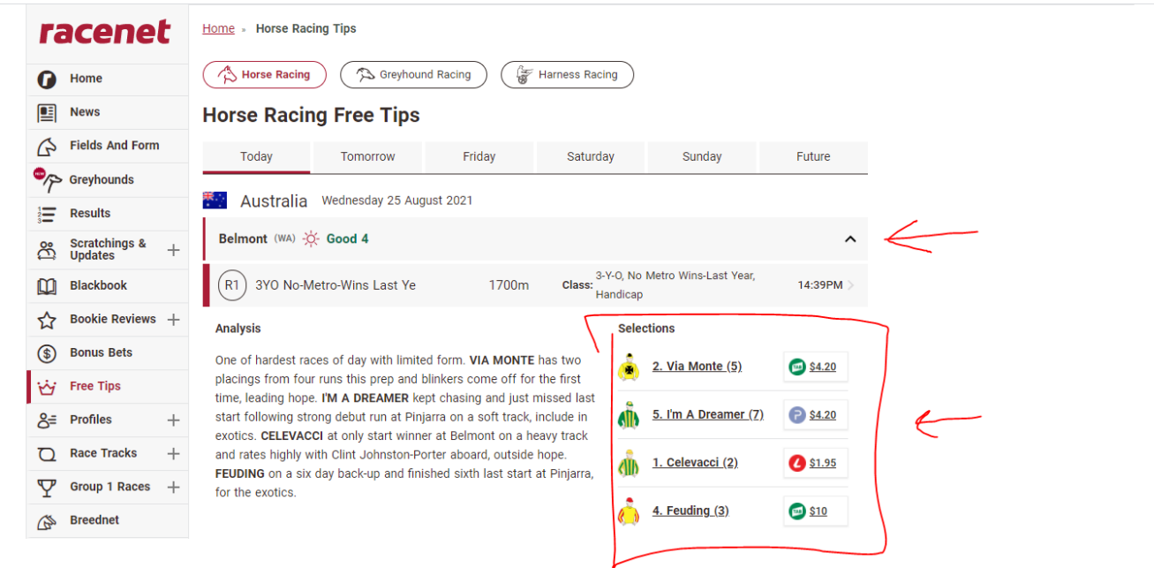

Tabtouch
All Races:
https://www.tabtouch.com.au/racing/races
Tips example:
https://www.tabtouch.com.au/racing/2021-08-25/pr/1
Click race preview and numbers are displayed
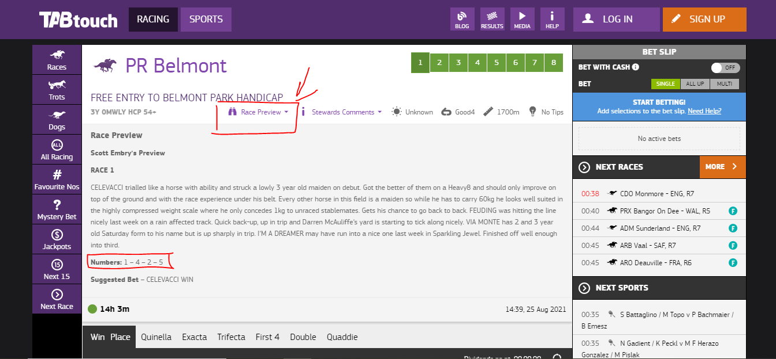

TAB
All Races:
https://www.tab.com.au/racing/meetings/today/R
Tips example:
https://www.tab.com.au/racing/2021-08-25/BELMONT/BEL/R/1
Click Tips Tab and return all 7 sets of tips Each can have heading TAB-Best Overall, Tab-Skyform Rating,etc
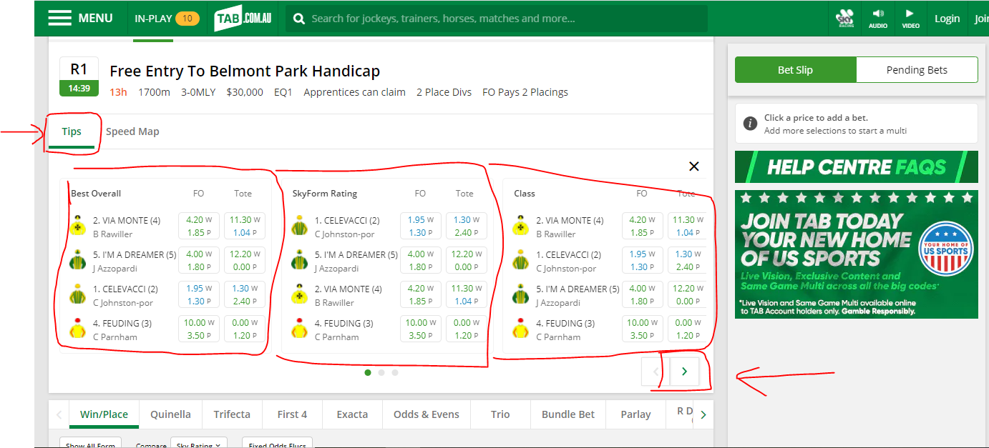

Punters
All Races:
https://www.punters.com.au/form-guide/
Tips example:
https://www.punters.com.au/form-guide/sandown-lakeside_204443/ladbrokes-punter-assist-plate-_1190904/#Overview
The selection order is 2,3,8,10 however this is displayed as a percentage
